**App Running instructions**

1. Open the project folder from NetBeans IDE

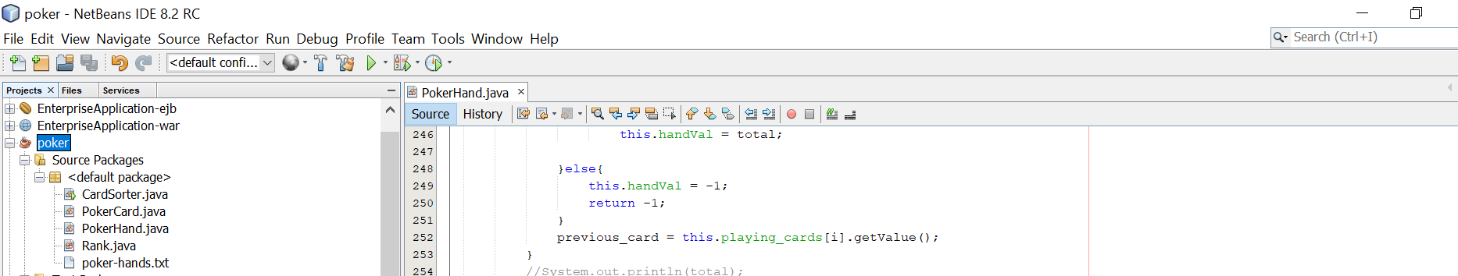

1. Run the application

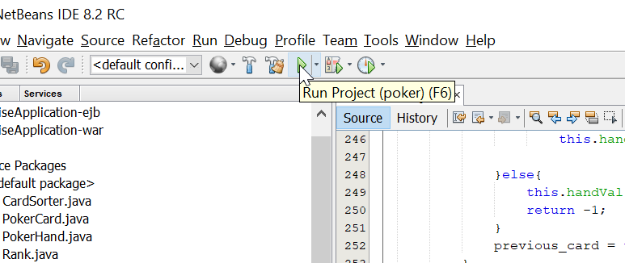

3) Input the 10 set of cards like below and press on enter twice.

Ex:

2H 9S 9C JD KH TD 4H JC 9H 8H

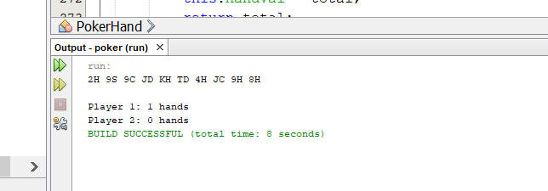

4) Player wins will be shown in output

5) You can exceute the jar file also by giving input in file format. Type the below command from the folder where you have placed input text file and jar file.

type poker-hands.txt | java -jar "C:\Users\dhanu\OneDrive\Documents\NetBeansProjects\poker\dist\poker.jar

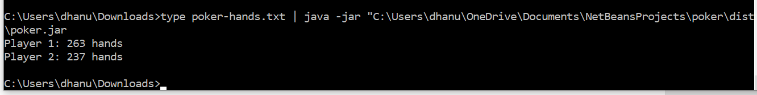

6) Output will be displayed on screen.